***AURA BRADLEY ELEMENT:***

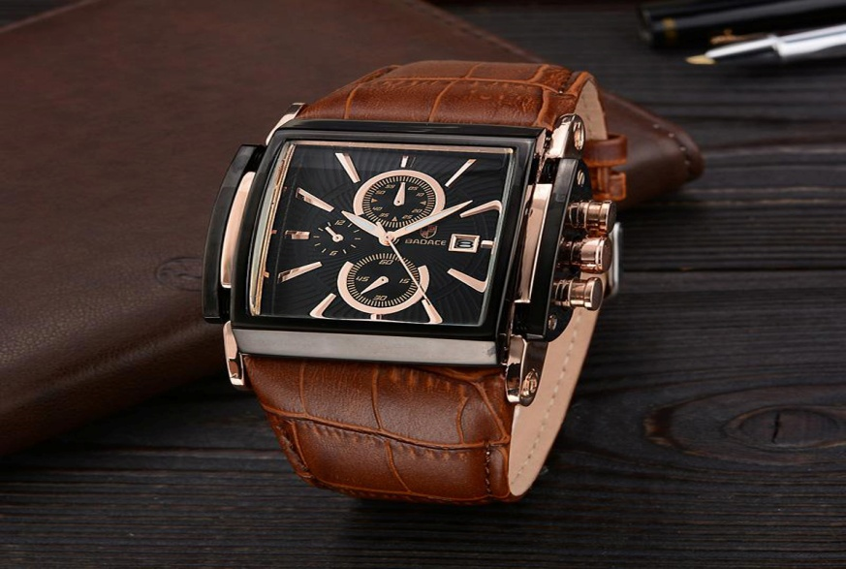

***DETAILS ABOUT THIS WATCH:***

DIMENSIONS: 40 mm (diameter) / 11.5 mm (thickness)  
CASE MATERIAL: Stainless Steel / Ceramics  
FITTING: Wrist size 6¼ – 8½ in (160 – 215 mm), 20 mm width  
WRISTBAND MATERIAL: Stainless Steel Mesh  
BATTERY: Renata 371 button cell watch battery  
WATER/SHOCK RESISTANCE: Bradley will easily withstand splashes or brief immersion in water, like getting caught in the rain or washing hands. However, it is not sufficiently resistant for water sports, swimming or bathing. Bradley is not intended to be worn during high level activity sports.

***SPACES:***

**MOV'T TYPE:**Quartz

**STRAP MATERIAL:**Mesh

**CASE SIZE:**40mm

**STRAP WIDTH:**20mm

**CASE THICKNESS:**12mm

***Price:***

***Rs:2,500***